Beginner Documentation: Pandas & Seaborn (Python)

1. Introduction
Python is one of the most popular languages for data analysis and visualization.
Two essential libraries are:
- Pandas → For data loading, cleaning, and manipulation
- Seaborn → For beautiful and easy statistical visualizations (built on Matplotlib)

2. Installing Required Libraries
- pip install pandas seaborn matplotlib

3. Pandas Basics
3.1 What is Pandas?
Pandas provides two main data structures:
- Series → 1-dimensional data
- DataFrame → 2-dimensional table (rows & columns)

3.2 Importing Pandas
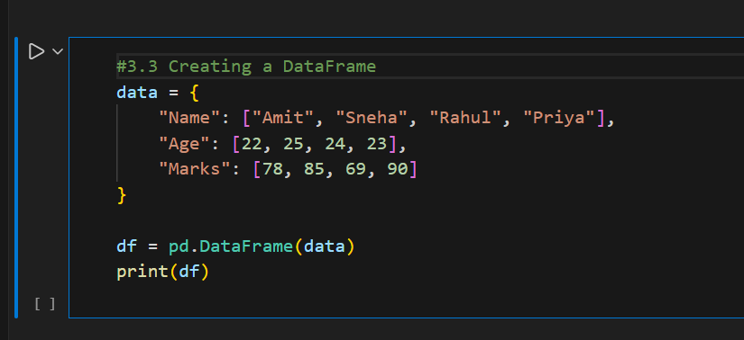
- import pandas as pd

Output:
A table with Name, Age, and Marks columns.
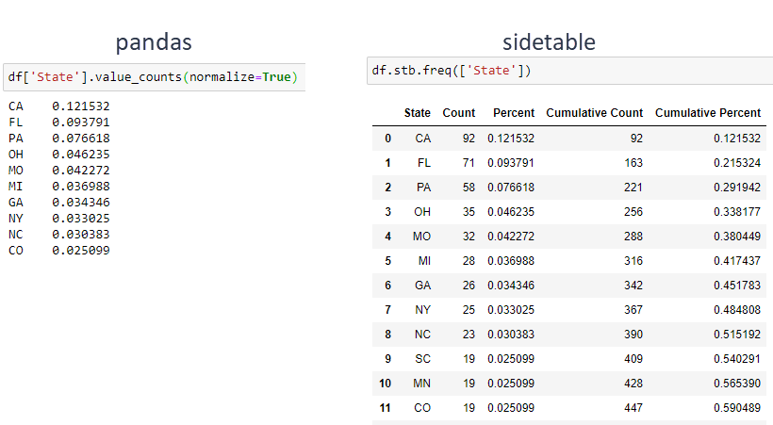
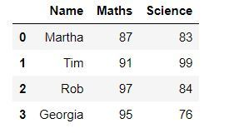

3.4 Reading Data from CSV
df = pd.read_csv("students.csv")
df.head()
- head() → shows first 5 rows
- tail() → shows last 5 rows

3.5 Understanding the Data
df.info()
df.describe()
- info() → data types & missing values
- describe() → statistical summary (mean, min, max, etc.)

3.6 Selecting Columns & Rows
df["Marks"] # Single column
df[["Name", "Age"]] # Multiple columns

df.iloc[0] # First row (index based)
df.loc[0, "Name"] # Label based access

3.7 Handling Missing Values
df.isnull().sum() # Check missing values
df.fillna(0, inplace=True)
df.dropna(inplace=True)

4. Introduction to Seaborn

4.1 What is Seaborn?
Seaborn is a high-level visualization library that makes plots:
- Cleaner
- More informative
- Easier than Matplotlib
import seaborn as sns
import matplotlib.pyplot as plt

5. Seaborn with Pandas Data
We will use the same DataFrame:
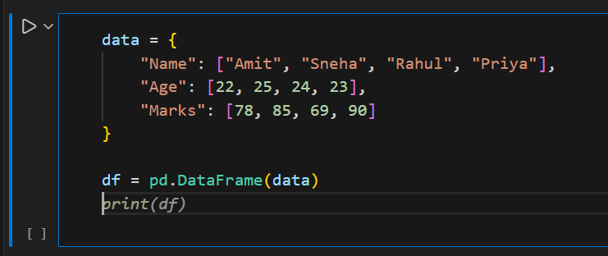
6. Basic Seaborn Plots
6.1 Bar Plot
sns.barplot(x="Name", y="Marks", data=df)
plt.title("Marks of Students")
plt.show()

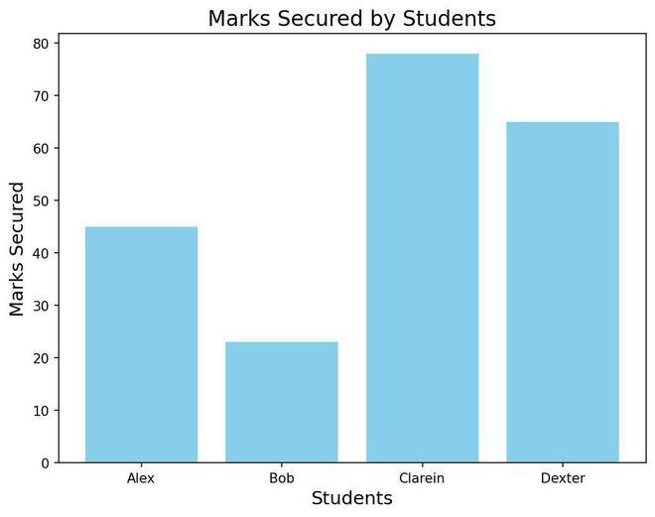
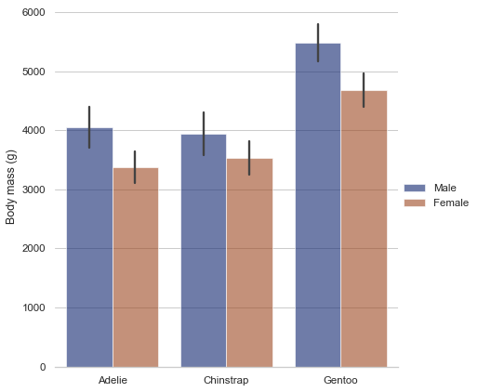

Use Case: Compare values across categories.
6.2 Line Plot
sns.lineplot(x="Age", y="Marks", data=df)
plt.title("Age vs Marks")
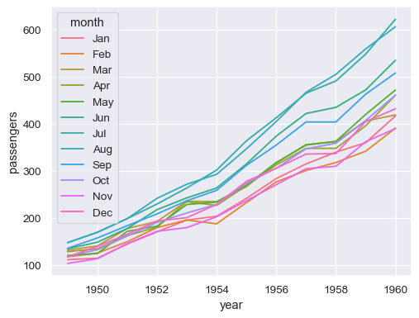
plt.show()

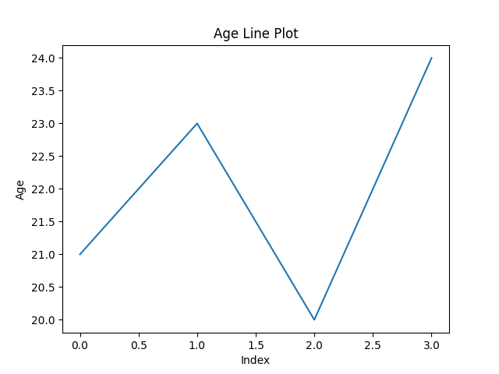
Use Case: Trends and progression.

6.3 Scatter Plot
sns.scatterplot(x="Age", y="Marks", data=df)
plt.title("Scatter Plot of Age vs Marks")
plt.show()
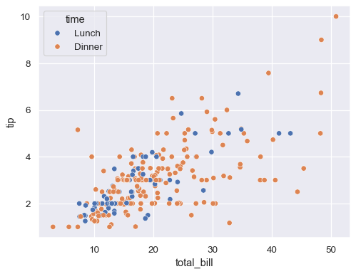

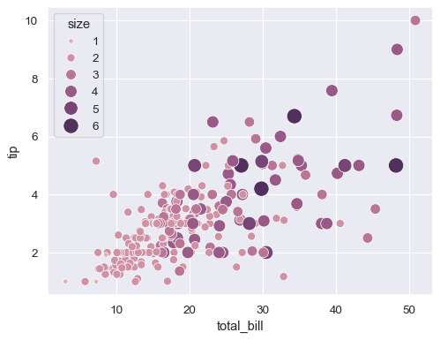

Use Case: Relationship between two numeric variables.

6.4 Histogram
sns.histplot(df["Marks"], kde=True)
plt.title("Distribution of Marks")
plt.show()
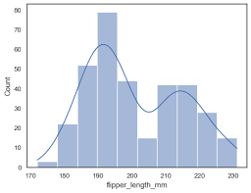
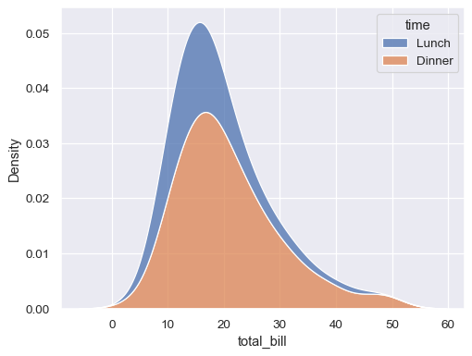

Use Case: Data distribution & frequency.

6.5 Box Plot
sns.boxplot(y="Marks", data=df)
plt.title("Box Plot of Marks")
plt.show()

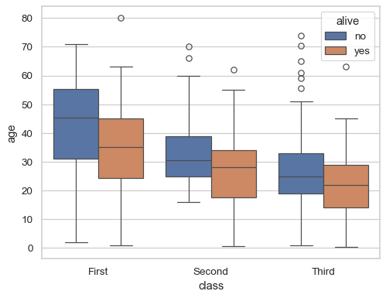

7. Styling with Seaborn
sns.set_style("whitegrid")
sns.set_palette("pastel")
Common styles:
- whitegrid
- darkgrid
- ticks

8. Why Use Pandas + Seaborn Together?
Pandas | Seaborn
Data cleaning | Data visualization
Fast analysis | Beautiful plots
CSV / Excel handling | Statistical insights
They complement each other perfectly.

9. Beginner Practice Tasks
- Load a CSV file using Pandas
- Find mean and max values
- Plot:
  - Bar plot
  - Histogram
  - Box plot
- Identify outliers using boxplot

10. Conclusion
Pandas helps you understand and prepare data, while Seaborn helps you see patterns visually.
Mastering these two libraries gives a strong foundation in Data Science, Analytics, and Machine Learning.

